**MongoDB Task**

**Question & Queries:**

1. Find all the information about each products

Query: **db.products.find({});**

Output:

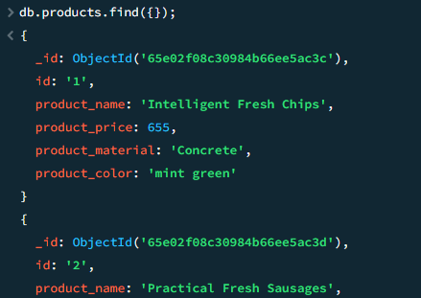

.

.

.

.

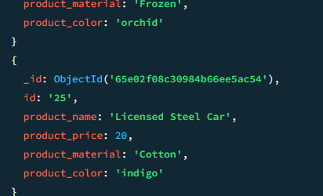

1. Find the product price which are between 400 to 800

Query: **db.products.find({"product_price": { $gte: 400, $lte: 800 }});**

Output:

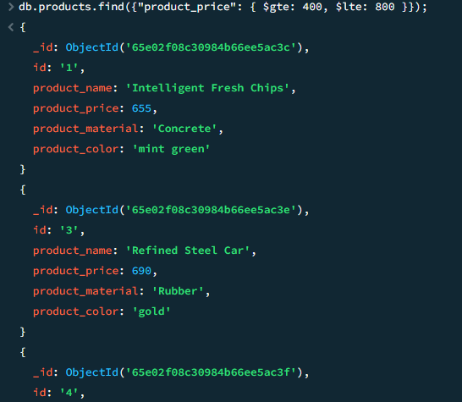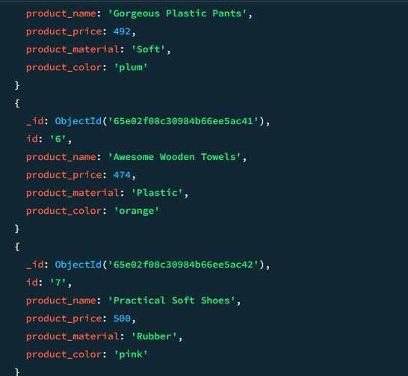

1. Find the product price which are not between 400 to 600

Query: **db.products.find({"product_price": { $not: { $gte: 400, $lte: 600 } }});**

Output:

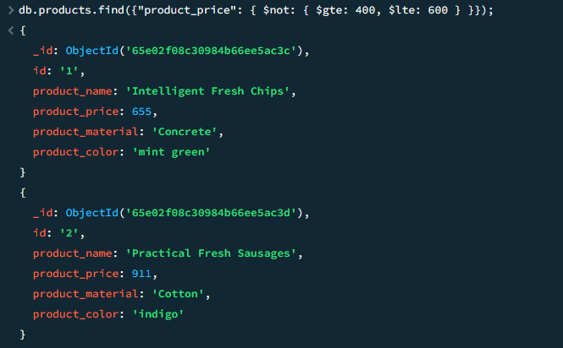

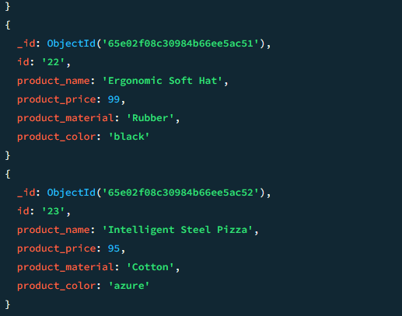

1. List the four product which are greater than 500 in price

Query: **db.products.find({"product_price": { $gt: 500 }}).limit(4);**

Output:

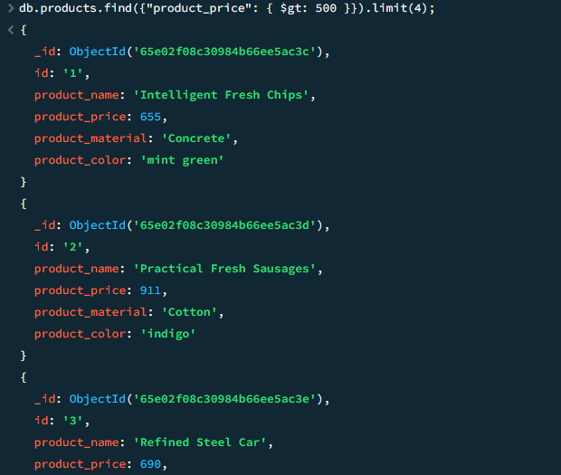

1. Find the product name and product material of each products

Query: **db.products.find({},{"product_name": 1, "product_material": 1});**

Output:

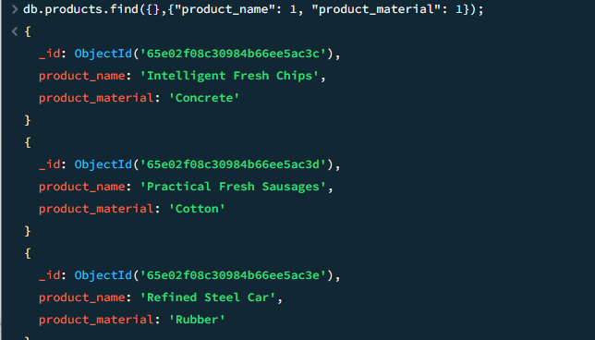

1. Find the product with a row id of 10

Query: **db.products.find({ "id":"10"});**

Output:

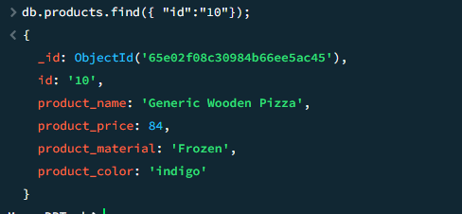

1. Find only the product name and product material

Query: **db.products.find({},{"product_name":1,"product_material":1,"_id": 0});**

Output:

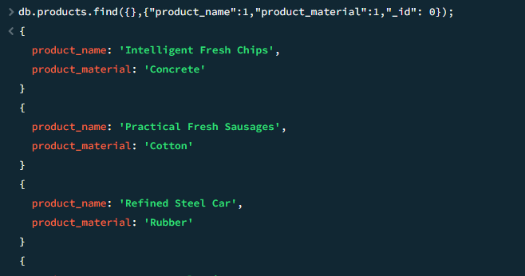

1. Find all products which contain the value of soft in product material

Query: **db.products.find({"product_material":{$regex:/soft/i}});**

Output:

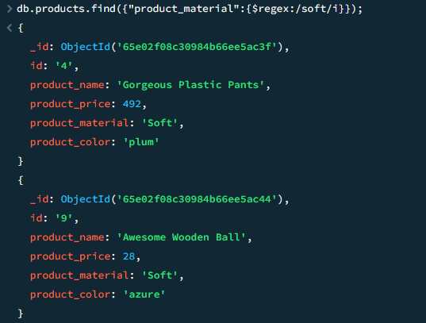

1. Find products which contain product color indigo  and product price 492.00

Query: **db.products.find({"product_color":"indigo","product_price":492.00});**

Output:



1. Delete the products which product price value are same

Query: **db.products.deleteMany({"product_price":{ $ne:null}});**

Output:

